common name: common backswimmer

scientific name: *Notonecta glauca* (Linnaeus, 1758) (Hemiptera: Notonectidae)

**Introduction – Distribution – Description** **– Behavior – Selected References**

**Introduction**

*Notonecta glauca*, the common backswimmer, is an aquatic insect most easily recognizable by their long hind legs and ability to inflict wounds to humans with their proboscis (mouthpart). Insects in the family Notonectidae are commonly referred to as backswimmers or greater water boatman. They propel themselves through the water on its back, like its common name implies. Insects commonly referred to as lesser water boatman are often in the family Corixidae.

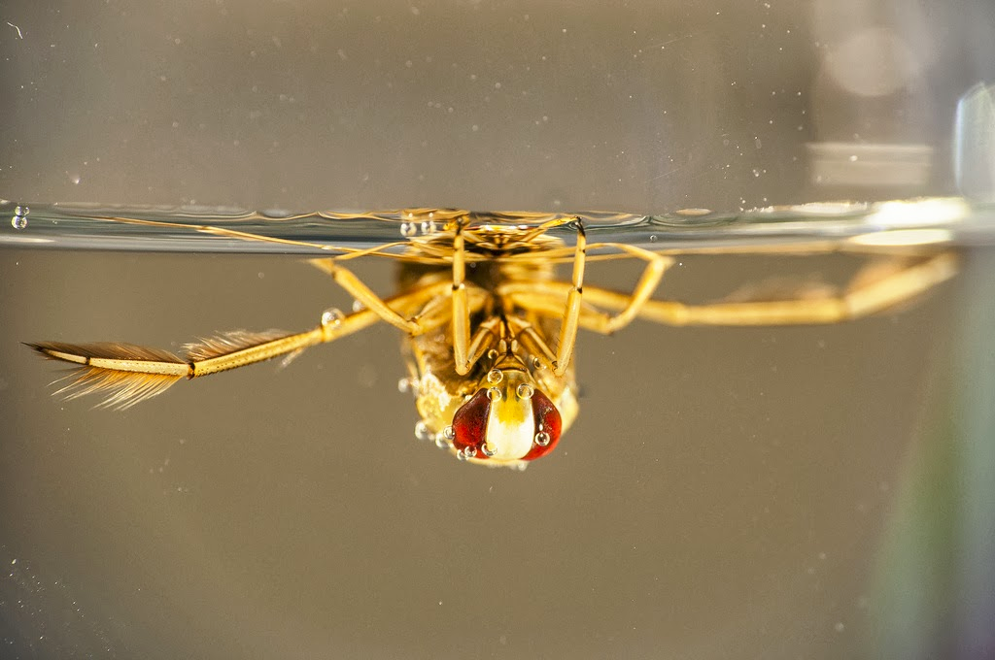

**Figure 1.** *Notonecta* sp. adult resting upside down underwater. Photograph by JRxpo.

**Distribution**

*Notonecta glauca* is found in many parts of Europe, including Hungary and Britain (Soós et al. 2009). Although most commonly found in Europe, it can range from some parts of northern Africa to west Siberia and north western China (Berchi 2013).

**Description**

**Eggs:** *Notonecta* sp. eggs are white in color and are attached to vegetation.

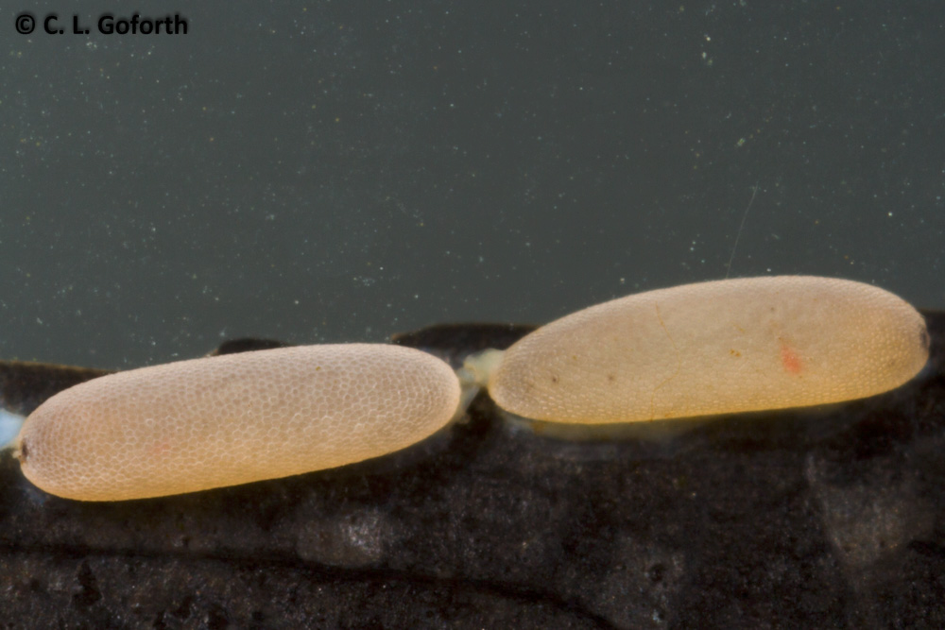

**Figure 2.** *Notonecta* sp. eggs on vegetation. Photograph by Chris Goforth. <https://thedragonflywoman.com>

**Adults:** Fully grown adults measure about 16 mm (Reynaldi et al. 2011).

**Behavior**

**Adults:** *Notonecta* sp. most commonly prey on other insect species, such as *Culex pipens* mosquito larvae in respect to *Notonecta glauca* (Reynaldi et al. 2011), but has been observed to prey on fish eggs, fry, and tadpoles (González and Leal 2010).

**Selected References**

Berchi G. 2013. *Notonecta glauca*, the common backswimmer, is an aquatic insect most easily recognizable by their long hind legs and ability to inflict wounds to humans with their proboscis (mouthpart). Zootaxa 3682: 121-132.

González A, Leal J. 2010. Predation Potential of Some Aquatic Insects (*Pantala*, *Coenagrion*, *Tropisternus,* *Notonecta* and *Sigara*) on Common Carp Fry. Journal of Applied Aquaculture

Reynaldi S, Meiser M, Liess M. 2011. Effects of the pyrethroid fenvalerate on the alarm response and on the vulnerability of the mosquito larva *Culex pipiens molestusto* the predator *Notonecta glauca*. Aquatic Toxicology 104: 56-60.

Soós N, Boda P, Csabai Z. 2009. First confirmed occurrences of *Notonecta maculata* and *N. meridionalis* (Heteroptera: Notonectidae) in Hungary with notes, maps, and a key to the Notonecta species of Hungary. Folia Entomologica Hungarica 70: 67-78.